Wellness Week at the College of Saint Elizabeth has been a tradition for years, bringing awareness to the public about health and wellness and how the food and lifestyle choices we make affect our bodies.

In Spring 2012, the College of Saint Elizabeth held the Annual Wellness Week. Faculty and staff from the chemistry, biology, and nutrition departments worked together to make this event a success for the college and the community.

National speaker, Dr. Mark Liponis, M.D., was the chosen guest speaker this year. He was a survivor of kidney cancer. Following his recovery he opened up a spa, Canyon Ranch, with the focus on Ultralongevity and Ultraprevention. Ultraprevention is a six week program that allows a person to get older without aging and to maintain health for all of life. He is also the author of three books, Ultraprevention, a New York Times Bestseller, UltraLongevity, and The Hunter/Farmer Diet Solution. Through his presentations in Dolan Hall, Dr. Liponis revealed the three simple steps to maintain health; 1) diet, 2) exercise, and 3) no stress. He also urged portion control and eliminating free radicals from the body. Following presentations, Dr. Liponis was available for Q&A and book signing.

Starting off the festivities, the BLUE PUNCH CARD GAME was in full effect this year. The game allowed students who participated in each activity to get their punch card stamped, making them eligible for entering their name in a drawing to win extravagant prizes, such as fragrance gift sets, night for two at the Madison Hotel, jewelry, gift cards, and more.

In Rose Dining Hall, students had the opportunity to “Make Your Plate with a Personal Nutrition Assistant.” The nutrition students were available as personal shopping assistants, guiding students in the right direction on their lunchtime food choices, according to the USDA MyPlate guidelines. A Wheel of Wellness was displayed in the back of the dining hall, testing student knowledge about nutrition. Winners were eligible to place their name in a drawing to win more prizes. Next to the wheel was a table set up with computers where students were invited to sit down and open a CSE Nutrition Journal account. With access to this account, students will be able to track all of the foods they eat and see if they are within their recommended calorie intake.

A lecture on “Rethink Your Drink” was held in the Foods Lab in Henderson Hall where students were given visual demonstrations on the nutritional status of beverages such as high sugar sodas and juices. The aim of this lecture was to encourage the consumption of water. Down the hall, body mass index measurements and body fat analysis were being conducted by qualified nutrition students. Participants were given an ideal body weight and range, followed by a brief counseling session for lifestyle changes that could be made to achieve these goals.

The week concluded with a 5K race/walk on Saturday morning, April 14th at 9:00 am. Racers gathered in front of Saint Joseph Hall, accompanied by LA Kickboxing, who lead them in a warm-up. Finishing the race in first place was graduating nutrition student, Yaniv Yarkoni, followed by the women’s first place runner, graduating nutrition student and cross-country team member, Brittney Hinton.
After the race participants enjoyed bagels, fruit, cookies, and coffee while certificates were handed out to participants. Live music was played by the Phil Moore Band, a brother duo, lead guitarist is a graduating nutrition student. Goody bags were also given to all participants, filled with donations from sponsors.

A special thank you to all the volunteers and sponsors who helped make this Wellness Week a success!

5K Race/Walk Photo Gallery

Warm up with LA Boxing
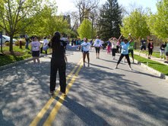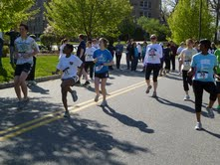
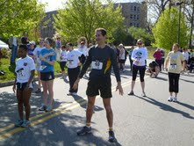





And they’re off! 

The Finish Line!




First Place Runner: Yaniv Yarkoni
First Place Female: Brittany Hinton




After the race 

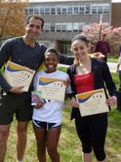

The Philip Moore Band

A special thank you the Foods and Nutrition Department, students, faculty, and staff who have joined together to help those of us graduating seniors make it to the end…

ake it to the end…

The Reyes and Graziano Families



